import pickle
#accepting data
def wdata():
f=open('cars.dat','ab')
ch=1
while ch==1:
name=input('entre the car name')
price=int(input('entre the price of the car'))
milage=int(input('entre the milage'))
series=input('entre the series')
data={'name':name,'price':price,'milage':milage,'series':series}
pickle.dump(data,f)
ch=int(input('do you want to entre datas, 1-yes,2-no'))
f.close()
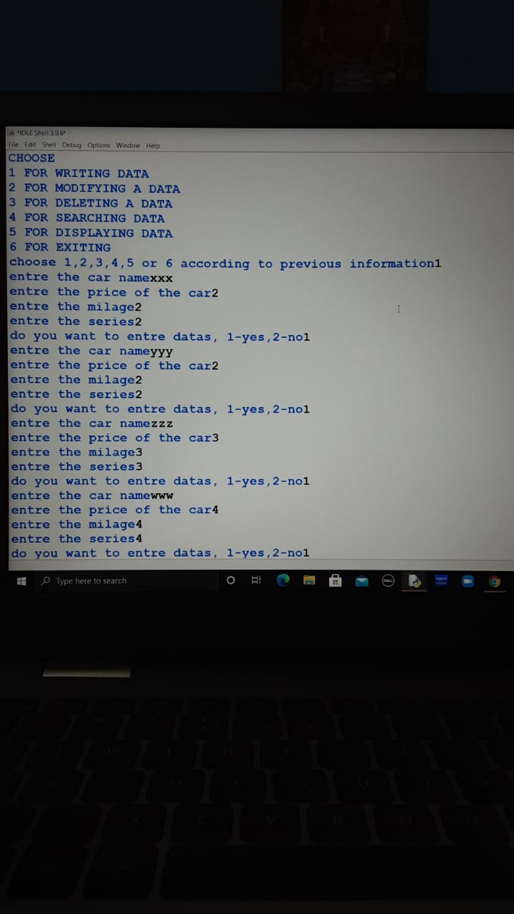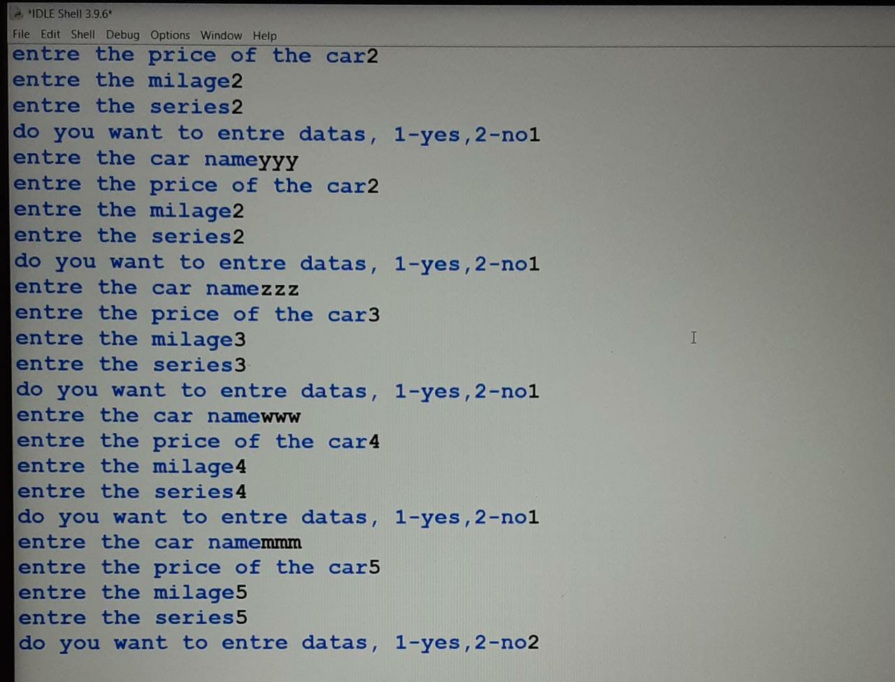
#reading data
def rdata():
f=open('cars.dat','rb')
print('{:^12}{:^10}{:^12}{:>15}'.format('NAME','PRICE','MILAGE','SERIES'))
while True:
try:
x=pickle.load(f)
print('{:^12}{:^10}{:^12}{:>15}'.format(x['name'],x['price'],x['milage'],x['series']))
except EOFError:
break
f.close()
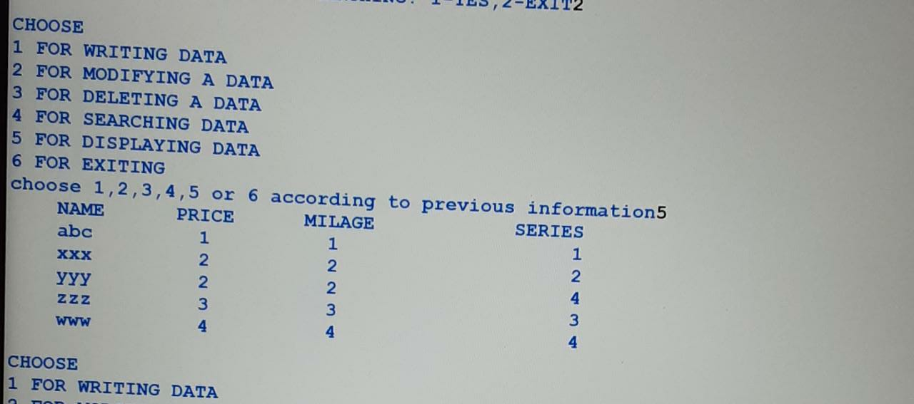
#searching data
def sdata():
ch=1
while ch==1:
f=open('cars.dat','rb')
info=input('entre the car name to be searched')
value=False
while True:
try:
x=pickle.load(f)
if x['name']==info:
print('record found')
print('{:^12}{:^10}{:^12}{:^20}'.format('NAME','PRICE','MILAGE','SERIES'))
print('{:^12}{:^10}{:^12}{:^20}'.format(x['name'],x['price'],x['milage'],x['series']))
value=True
except EOFError:
break
if value==False:
print('record not found')
f.close()
ch=int(input('DO YOU WANT TO CONTINUE SEARCHING? 1-YES,2-EXIT'))
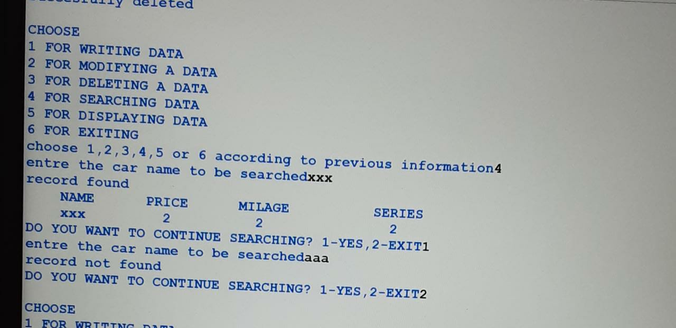
#modifing data
def mdata():
f=open('cars.dat','rb')
data=[]
info=input('entre the name of car thats data to be modified')
mod=int(input('which data is to be modified? 1 for price, 2 for milage ,3 for series'))
new=int(input('entre the new data'))
while True:
try:
data.append(pickle.load(f))
except EOFError:
break
value=False
for i in range(len(data)):
if data[i]['name']==info:
print('data before modification:',data[i])
if mod==1:
data[i]['price']=new
elif mod==2:
data[i]['milage']=new
elif mod==3:
data[i]['series']=new
else:
print('invalid input')
print('data after modification:',data[i])
value=True
if value==False:
print('the car doesnot exist in the file')
f.close()
f1=open('cars.dat','wb')
for x in data:
pickle.dump(x,f1)
if value==True:
print('')
print('succesfully modified')
f1.close()
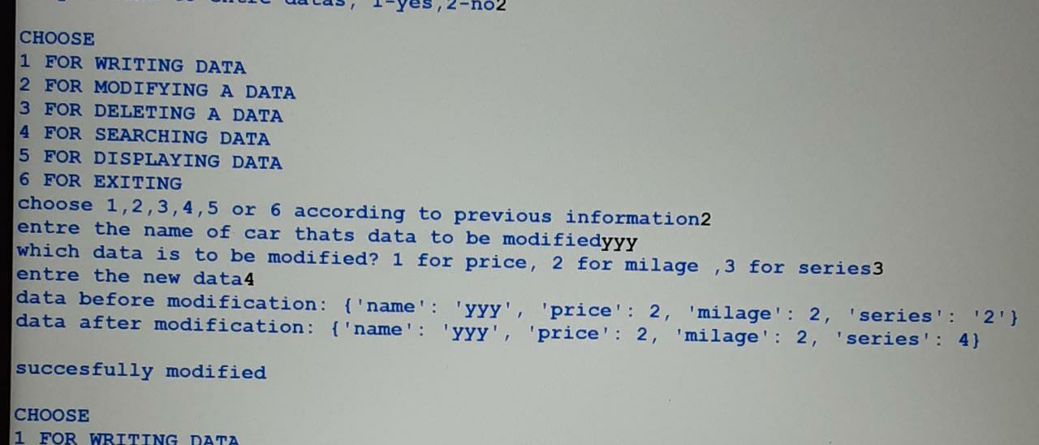

#deleting data
def ddata():
f = open('cars.dat','rb')
info=input('entre the name of car thats detailes to be delted')
data = []
while True:
try:
rec = pickle.load(f)
data.append(rec)
except EOFError:
break
f.close()
f = open('cars.dat','wb')
for x in data:
if x['name']==info:
print('')
print('succesfully deleted')
continue
pickle.dump(x,f)
f.close()
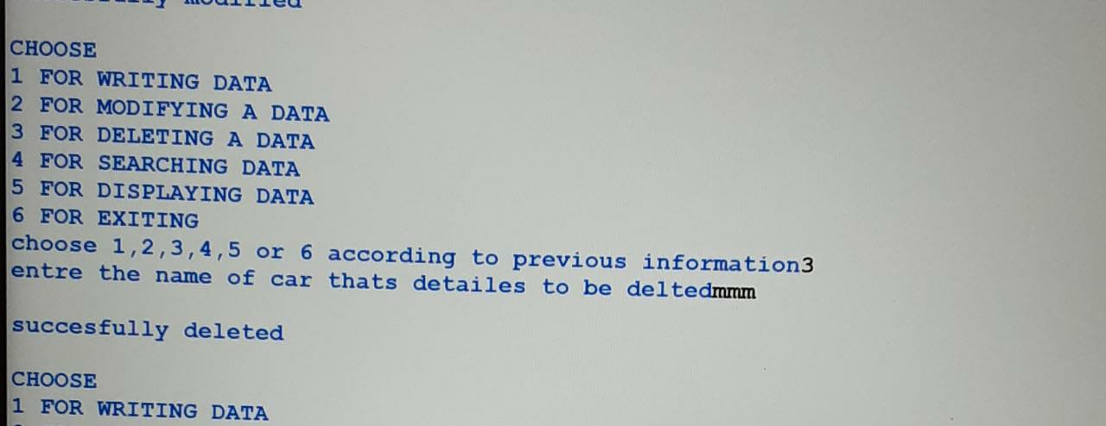
while True:
print(' ')
print('''CHOOSE
1 FOR WRITING DATA
2 FOR MODIFYING A DATA
3 FOR DELETING A DATA
4 FOR SEARCHING DATA
5 FOR DISPLAYING DATA
6 FOR EXITING''')
choice=int(input('choose 1,2,3,4,5 or 6 according to previous information'))
if choice==1:
wdata()
elif choice==2:
mdata()
elif choice==3:
ddata()
elif choice==4:
sdata()
elif choice==5:
rdata()
elif choice==6:
print(' ')
print('{:^50}'.format('THANK YOU'))
break
else:
print(' ')
print('invalid choice,try again')
